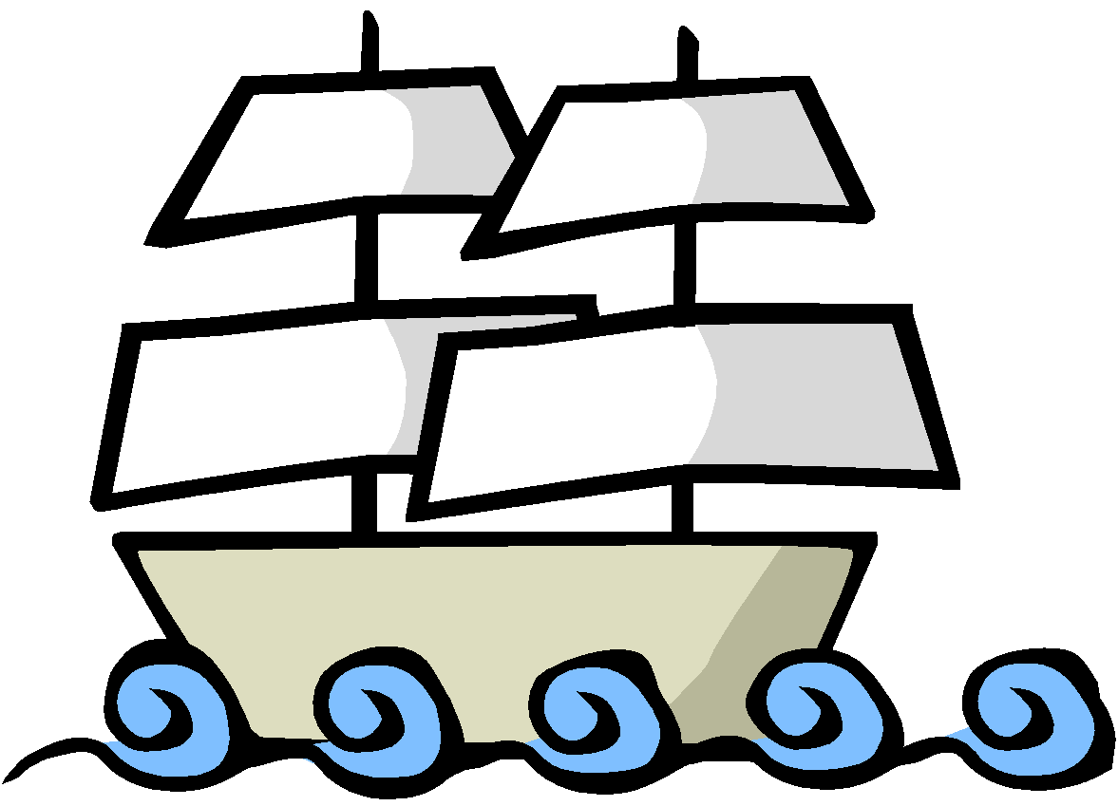
Partners:_________________________________________________________ Explorer: ___________________
Explorer Museum - Project Rubric
Requirements | Student Grade | Points  Possible
Elements of Your Exhibit: Use the following items to research, display, and present your explorer. Be creative with your display format.
- Notes Page  - Notes Page completely filled out  - cite your sources |  | /20
- Title  - Explorer’s Name  - Country of Origin  - Dates of Exploration |  | /10
- Basic Information Sheet  - Reasons/Goals for Exploration (minimum 1)  - Positive Impacts (minimum 1)  - Negative Impacts (minimum 1)  - Include an image of your explorer |  | /20
- Artifact #1  - 21st Century Journal: Create a 21st century version of a journal. You will log the experiences of your explorer's journey as if they had access to social media. Your posts must match the format of your chosen social media page.  - Must include 2-3 posts  * Ideas for Journal:  - Series of Facebook posts  - Series of Instagram posts  - Series of Twitter posts |  | /20
- Artifact #2  - Explorers Tool Advertisement: Create advertisement for an important navigational tool that was used during the Age of Exploration.  - Could be a video(like a commercial) or it could be written.  - Advertisement should include image of tool, what it was used for, famous explorers who may have used it, and a price).  - Compass  - Astrolabe  - Telescope  - Caravel |  | /20
Overall Product/Presentation:  - The final product should be neat, creative and well laid out. |  | /10
COMMENTS: |  | /100

